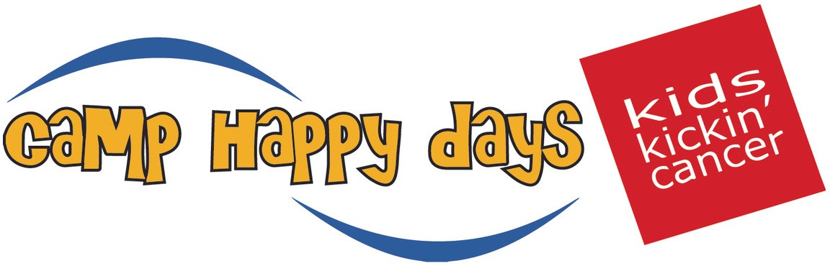
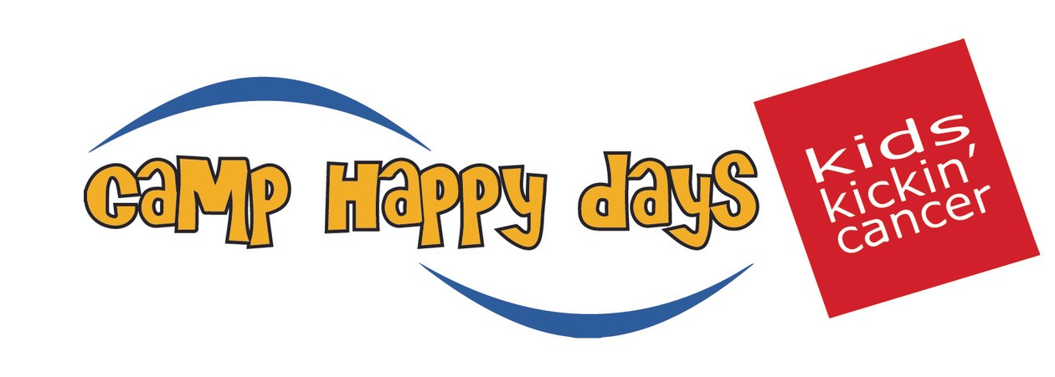
Camp Happy Days Programs Descriptions
Day Programs
Doodlebug Programs
Programs designed for children and their siblings ages 0-9 years old. Doodlebug programs are held throughout the year and allow families to engage in fun activities with other families, Camp Happy Days staff, and volunteers.
Pre-teen Programs
Programs designed for children and their siblings ages 10-13. Our pre-teen programs are held throughout the year and provide children and their siblings the opportunity to reconnect, participate in fun therapeutic activities, and bond with other pre-teens who are going through a similar experience.
Family Events
Camp Happy Days staff and volunteers host quarterly activities for CHD families to participate in together. Activities include game nights, movie nights, and family dinners.
Holiday Festival
A signature holiday program for Camp Happy Days families to gather and celebrate the upcoming holidays.

Overnight Programs
Camp Happy Days Overnight Weeklong Summer Camp
This weeklong, flagship event in Summerton, SC is for children diagnosed with cancer and their siblings, ages 5-16. This powerful, life changing experience helps children build self-esteem, courage, confidence, and trust in an incredibly active, high-energy environment designed just for them.
Family Weekends
Twice a year, Camp Happy Days host a overnight weekend programs designed for Camp Happy Days families where they have the opportunity to connect, learn, share, and experience the magic of camp together.
Extreme Teen Weekends
Teen weekends are designed for teenagers and their siblings ages 13-18. This program allows teens to interact with one another, share experiences, and engage in a variety of fun activities. Teen weekends are hosted twice a year, one in the fall and one in the spring.

Hospital Programing
Happy Hospital Days at MUSC
Camp Happy Days staff and volunteers bring the CHD experience to the hospital. Once a month, we spend the day at MUSC Shawn Jenkins Children’s Hospital doing crafts and activities with the patients on the pediatric oncology unit. During a hospital stay, families can request a special visit from Camp Happy Days staff and volunteers. Families can choose to receive a nice meal, make their favorite craft, play games, or have story time.
Outpatient Clinic Visits – FACT Clinic & Brain Tumor Clinic
Follow up After Cancer Treatment (F.A.C.T) Clinic
Camp Happy Days provides healthy snacks and activity bags 24 times a year for patients and families who attend. Follow-up After Cancer Treatment (F.A.C.T Clinic), a comprehensive clinic for long-term pediatric cancer survivors at MUSC Children’s Health Summey Medical Pavilion.
Brain Tumor Clinic
Camp Happy Days brings arts and crafts activities and healthy snacks to patients and families during their clinic visit. Brain Tumor Clinic occurs monthly at MUSC Children’s Health Summey Medical Pavilion for children who have recently finished treatment for a brain tumor.
Family Resources
Family Financial Assistance
To ease the financial strain that pediatric cancer puts on families, Camp Happy Days provides financial assistance to qualifying families to assist with bills, groceries, gas and other everyday needs.
Holiday Giving
Volunteers, donors, and friends of Camp Happy Days sponsor a family or a child diagnosed with cancer, to help fulfill their children’s holiday wishes.
Virtual Programs
Since 2020, we have developed a variety of virtual programming that is available to all Camp Happy Days children and their siblings. Virtual programming has provided a safe space for all CHD families to interact with each other, even from afar.
Virtual Camp
Virtual Camp takes place in June each summer. Each camper receives a special themed box that includes all items needed for the entire week of camp! These boxes are filled to the brim with opportunities to bring the benefits of Camp to their home and engage and connect with their camp family Virtual Camp has not only allowed us to serve children at their homes but also to start serving children in the hospital or currently quarantined due to their treatment plan.
Virtual Doodlebug Bedtime Stories
Doodlebug Bedtime Stories take place once a month for children and their siblings ages 0-9. Each month is geared toward a different theme including a fun children’s book and activity. Our goal is to connect, learn, and laugh together.

