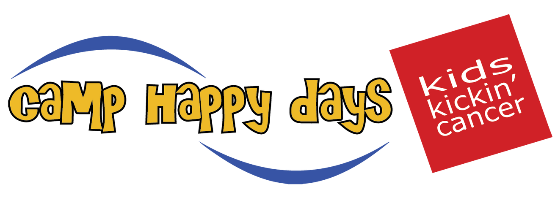

Camp Happy Days Programs

Family Programs & Resources

Family Financial Assistance
To ease the financial strain that pediatric cancer puts on families, Camp Happy Days provides financial assistance to qualifiying families to assist with bills, groceries, gas and other everyday needs.

Family Weekend
A weekend designed for Camp Happy Days families where they have the opportunity to connect, learn, share, and experience the magic of camp together.

Family Nights
Camp Happy Days staff and volunteers host quarterly activities for CHD families to participate in together. Activities include game nights, movie nights, and family dinners.

Holiday Festival
A signature holiday program for Camp Happy Days families to gather and celebrate the upcoming holidays.

Holiday Giving
Volunteers, donors, and friends of Camp Happy Days sponsor a family or a child diagnosed with cancer, to help fulfill their children’s holiday wishes.

Hospital Programs

In-Hospital Programming
Camp Happy Days staff and volunteers brings the CHD experience to the hospital. Once a month, we spend the day at MUSC Shawn Jenkins Children’s Hospital doing crafts and activities with the patients on the pediatric oncology unit.

CHD Hospital Check-Ins
During a hospital stay, families can request a special visit from Camp Happy Days staff and volunteers. Families can choose to receive a nice meal, make their favorite craft, play games, or have story time.

Dream Dates
A customized day or night event created to make dreams come true for children struggling with treatment or celebrating the end of treatment. Activities are geared toward the child’s interests and they can choose a special or meaningful experience for Camp Happy Days to bring to life.

Outpatient Clinic Visits

F.A.C.T. Clinic
Camp Happy Days provides healthy snacks and activity bags 24 times a year for patients and families who attend. Follow-up After Cancer Treatment (F.A.C.T Clinic), a comprehensive clinic for long-term pediatric cancer survivors at MUSC Children’s Health Summey Medical Pavilion.

Brain Tumor Clinic
Camp Happy Days brings arts and crafts activities and healthy snacks to patients and families during their clinic visit. Brain Tumor Clinic occurs monthly at MUSC Children’s Health Summey Medical Pavilion for children who have recently finished treatment for a brain tumor.

Age-Specific Programs

Doodlebug Programs
Programs designed for children and their siblings ages 0-9. Doodlebug programs are held throughout the year and allow families to engage in fun activities with other families, Camp Happy Days staff, and volunteers.

Pre-teen Programs
Programs designed for children and their siblings ages 10-13. Our pre-teen programs are held throughout the year and provide children and their siblings the opportunity to reconnect, participate in fun therapeutic activities, and bond with other pre-teens who are going through a similar experience.

Teen Weekends
Teen weekends are designed for teenagers and their siblings ages 13-18. This program allows teens to interact with one another, share experiences, and engage in a variety of fun activities. Teen weekends are hosted twice a year, one in the fall and one in the spring.

Virtual Programs

Virtual Programs
Since 2020, we have developed a variety of virtual programming that is available to all Camp Happy Days children and their siblings. Virtual programming has provided a safe space for all CHD families to interact with each other, even from afar.

Virtual Doodlebug Bedtime Stories
Doodlebug Bedtime Stories take place once a month for children and their siblings ages 0-9. Each month is geared toward a different theme including a fun children’s book and activity. Our goal is to connect, learn, and laugh together.

Virtual Hangout
Camp Happy Days staff and volunteers host quarterly virtual hangouts for all children and siblings ages 0-18. We will engage in a variety of activities such as cooking, playing games, or just a time to connect and catch up together.

